Printmaking Class Supply List
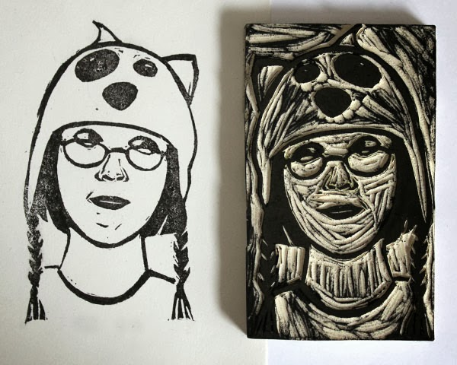

Students will need to purchase their own paper on which to print.
The instructor will go over the specific papers needed on the first day of class.

